# ExaIO

In pursuit of more accurate real-world systems modeling, scientific applications at exascale will generate and analyze massive amounts of data. One critical requirement for these applications to be able to complete their science mission is the capability to access and manage these data efficiently on exascale systems. Parallel I/O, the key technology behind moving data between compute nodes and storage, faces monumental challenges from new application workflows, as well as the memory, interconnect, and storage architectures considered in the designs of exascale systems. The ExaIO project is delivering the Hierarchical Data Format version 5 (HDF5) library and the UnifyFS file system to efficiently address these storage challenges.

## Project Details

In the future, parallel I/O libraries and file systems must be able to handle file sizes of many terabytes and I/O performance much greater than what is currently achievable to satisfy the storage requirement of exascale applications and enable them to achieve their science goals. As the storage hierarchy expands to include node-local persistent memory, solid-state storage, and traditional disk and tape-based storage, data movement among these layers must become much more efficient and capable. The ExaIO project is addressing these parallel I/O performance and data management challenges by enhancing the HDF5 library and developing UnifyFS to use exascale storage devices.

HDF5 is the most popular high-level I/O library for scientific applications to write and read data files at supercomputing facilities, and it has been used by numerous applications. The ExaIO team is developing various HDF5 features to address efficiency and other challenges posed by data management and parallel I/O on exascale architectures. The ExaIO team is productizing HDF5 features and techniques that were previously prototyped, exploring optimizations on upcoming architectures, and maintaining and optimizing existing HDF5 features tailored for the exascale applications. They are also adding new features, including transparent data caching in the multilevel storage hierarchy, topology-aware I/O-related data movement, full single-writer and multi-reader for workflows, asynchronous I/O, and I/O from accelerator processors (i.e., GPUs).

The ExaIO team is developing UnifyFS, a user-level file system highly specialized for shared file access on high-performance systems with distributed node-local storage. Although distributed node-local storage offers significant performance advantages, it is extremely challenging to use it for applications that operate on shared files. UnifyFS creates a shared file system namespace across the distributed storage devices in a job, greatly simplifying their use. Thus, UnifyFS addresses a major usability factor of pre-exascale and exascale systems. UnifyFS transparently intercepts I/O calls from applications and I/O libraries, allowing UnifyFS to be cleanly integrated with applications and other software, including I/O and checkpoint/restart libraries.

## Principal Investigator(s):

Suren Byna, Lawrence Berkeley National Laboratory

## Collaborators:

Lawrence Berkeley National Laboratory, Lawrence Livermore National Laboratory, Oak Ridge National Laboratory, Argonne National Laboratory, the HDF Group

## Progress to date

The ExaIO team has improved the HDF5 library in terms of performance and The team developed the Virtual Object Layer (VOL) feature to open the HDF5 applications performance interface (API) and developed several optimizations to improve HDF5 performance. These optimizations include the ability to stage the data in a temporary fast storage location, such as burst buffer, and move the data to the desired final destination asynchronously; a caching VOL connector to use multiple levels of memory and storage devices; and a capability that enables a single writing process to update an HDF5 file while multiple reading processes access the file in a concurrent, lock-free manner. The team also demonstrated the benefits of moving data between GPU accelerators and storage asynchronously. The HDF5 team actively works with several ECP applications (e.g., EQSIM, ExaSky, ExaStar, QMCPACK, WarpX) to integrate HDF5 API and apply performance optimizations.

The team fully redesigned and implemented the UnifyFS internals, resulting in 3.5× faster read performance. The team replaced the previous metadata management infrastructure with new local and global structures for fast access to file information and completely removed the dependence on message passing interface (MPI) for portability. The team also extensively tested and validated its support for HDF5 (parallel and serial) and MPI-IO applications.

## 参考文献

ExaHDF5: Delivering Efficient Parallel I/O on Exascale Computing Systems

HDF5 Cache VOL: Efficient and Scalable Parallel I/O through Caching Data on Node-local Storage

https://www.exascaleproject.org/research-project/exaio/

https://exascale.llnl.gov/

# Unify:

Unify: Distributed Burst Buffer File System

Fast, scalable I/O performance over distributed storage

Hierarchical storage systems are the wave of the future for high performance computing (HPC) centers like LLNL’s Livermore Computing Complex. The Unify project aims to improve I/O performance by utilizing distributed, node-local storage systems. This design scales bandwidth and capacity according to the computer resources used by a given job. Furthermore, Unify avoids inter-job interference from parallel file systems or shared burst buffers.

Unify is a suite of specialized, flexible file systems—the first is available on GitHub with more on the way—that can be included in a user’s job allocations. A user can request which Unify file system(s) to be loaded and the respective mount points. Tests on LLNL’s [Catalyst cluster](https://hpc.llnl.gov/hardware/platforms/catalyst) show more than 2x improvement in write performance.

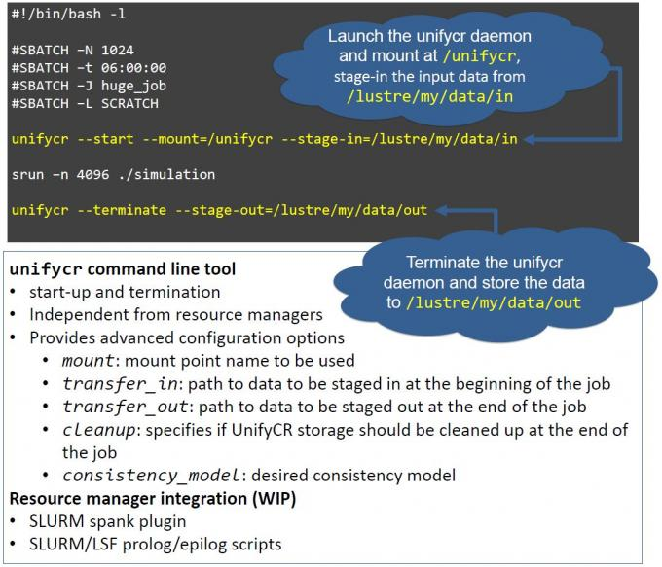

***Figure:*** UnifyFS supports checkpoint/restart workloads. Like all current and future Unify file systems, UnifyFS is launched at the beginning of a batch job. Additional information about UnifyFS configuration can be found on Read the Docs, linked below. (Click to enlarge.)

https://computing.llnl.gov/projects/unify

# 可视化

https://www.exascaleproject.org/research-group/data-and-visualization/

